Site Planning - Laundry List

* Home page
* Donation page
* Services provided
* About the fire company (history, etc)
* Updates page for news about the fire company
* Recent events page to show recent fires
* Page for honoring the firefighters who went above and beyond in their service
* Social media
* Contact Us page
* Feedback page
* Signup page for aspiring volunteers
* Training information
* Press info page
* Photo gallery
* Fire safety pages
* Parades
* Current members & Leaders

Site Planning – Site Map

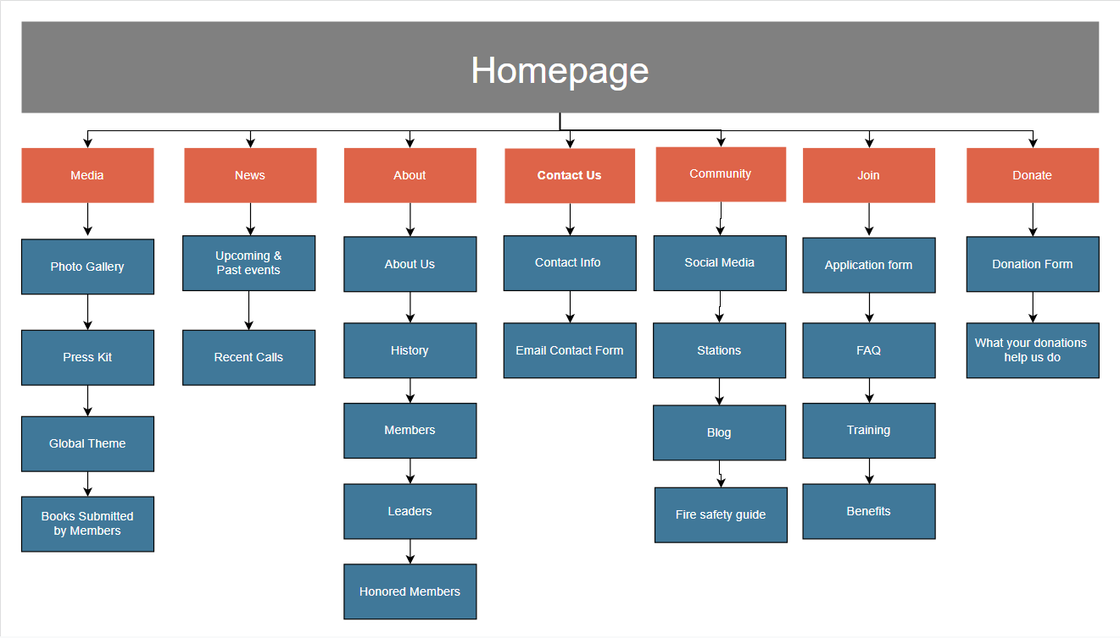

Site Planning - Marketing Statement

The main target for this website will be the local community and the press. Due to this, I designed the site map to contain images and news for these locals.

The news and community pages are targeted to entice an attachment from the locals by sharing images of people they may know being rescued; additionally, there is a page for seeing the calls as they come in. I also included a separate donation page that will also contain a brief summary of why donations from the community are important; as well as highlighting that a new fire truck is needed. The Join page is intended for new volunteers since they will likely be locals as well; as such it will include an FAQ and basic info on volunteering.

Following the community-driven mindset, I also felt it was a good idea to include an about us style page to share the fire company’s motto and history. It will also be used to share and honor notable members -both present and past- to the community. I also planned to have additional information such as the current leadership

Lastly, the Media page was designed to include images from fires and rescues. This page was made to show the community successful rescues; it will also be used to provide a press kit to the media companies.

Site Planning - Design Brief

For the design, I feel like a modern tone with a touch of conservative elements would fit a fire company. I also decided to use a color palette that reflects a firefighter’s gear and equipment. I would want to focus on making the layout easy to navigate; in addition to providing the important information on the fire company itself. I feel that a navbar with the logo of the fire company in the center with the main pages on either site would look nice. Each page would stick to a relatively similar template to ensure consistency.

The most important pages to get right would be the homepage. If the homepage is off-putting or difficult to read it could make the viewers disinterested or leave. And since the community will include the elderly and computer-illiterate people, the easy and simple navigation would be a must. Keeping the community engaged and unhindered by the website would be the best way to ensure the most support for donations and the fire company.

Color Palette:  
